Project Title: **Task Tracker**

**Group Members**

1. Jayden Mathenge-SCT211-0030/2022
2. Joseph Muema-SCT211-0039/2022
3. Kelly Kasina-SCT211-0038/2022
4. Terry Mutheu-SCT211-0073/2022
5. Joseph Njenga-SCT211-0040/2022

**Introduction:**The Task Tracker web application was designed to help users manage and keep track of their tasks in a simple and organized manner.

**Target Audience:**This application is targeted at individuals, students, and professionals that need a straightforward tool to manage their daily tasks and responsibilities.

**Goals:**

* Allow users to create, edit, and delete tasks.
* Provide a user-friendly interface for task management.
* Implement a simple notification system for upcoming tasks.
* Enable users to mark tasks as completed.

**FLOWCHART EXPLANATION (FLOWCHART ON NEXT PAGE)  
Start:** The starting point of the flowchart.  
**Home Page:** Users begin at the home page, leading to the task list.  
**Task List:** Display a list of tasks with options to add, edit, or mark tasks as completed.  
**Add Task:** Redirects to the Create Task page.  
**Create Task Page:** Users can input task details and save the task.  
**Edit Task:** Users can edit existing tasks, leading to the Task Form page.  
**Save Task:** After editing or creating a task, users can save the task details.  
**Task Form Page:** Display the form for creating or editing tasks.  
**Mark as Completed:** Users can mark tasks as completed, leading to the Task Completed page.  
**Task Completed:** Confirmation that the task has been marked as completed.  
**Completed Tasks List:** Display a list of completed tasks.  
**End:** The end point of the flowchart.

**Flow Chart**

**START**

**END**

MARK AS COMPLETED

TASK FORM PAGE

CREATE TASK PAGE

TASK LIST

COMPLETED TASKS LIST

TASK LIST

SAVE TASK

HOME PAGE

TASK LIST

EDIT TASK

TASK COMPLETED

ADD TASK

**Rough Sketches:**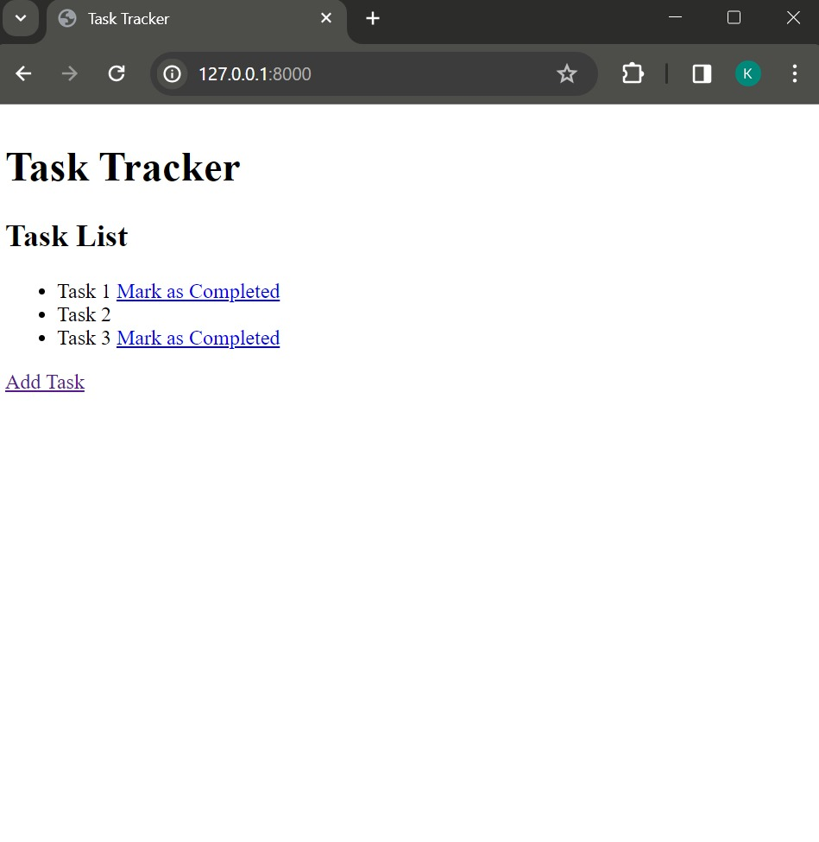

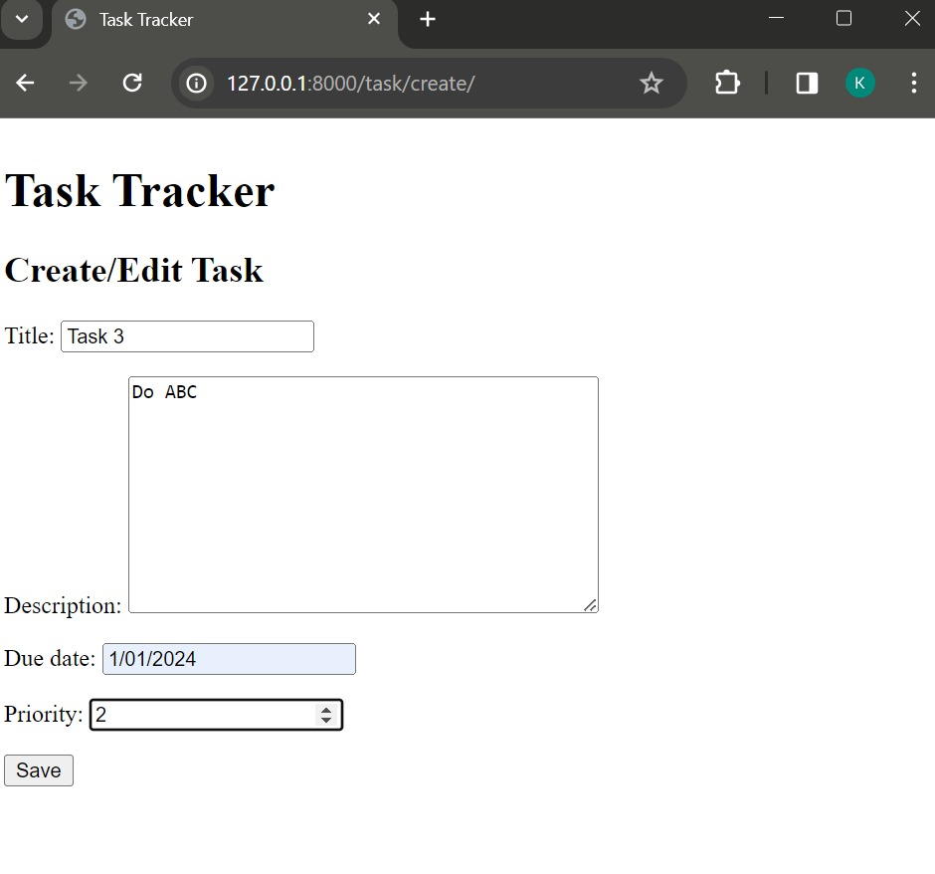

**Conclusion**The task tracker web application provides a straightforward solution for users to manage their tasks efficiently. With its simple and intuitive design, users can easily stay organized and on top of their responsibilities.